ESTABLISHING THE SAFETY INFRASTRUCTURE FOR A NUCLEAR POWER PROGRAMME

IAEA WORKSHOP ON
LEADERSHIP AND MANAGEMENT SYSTEM FOR REGULATORY BODY (WS-8)

Workshop Exercises

Background information and instructions

- Introduction
The proposed exercises below aim at developing understanding and enhancing knowledge on the key aspects of leadership and management system for regulatory body.
- Background
The Lilliput country took an interest in nuclear power in 2008. Since then, the State has taken a number of initiatives for making a knowledgeable decision on whether or not to introduce nuclear power. In 2011 the Government decided to build two nuclear power plants (NPP) in the country. The national plan is to have the two NPP to be provided by two different vendors.
Up to now, the Lilliput National Utility (LNU) has operated only conventional power facilities. LNU has been tasked by the Government to get prepared to become the future operating organization of the two NPP. This includes, in early phase 3, the management of the bidding process for acquiring NPPs.

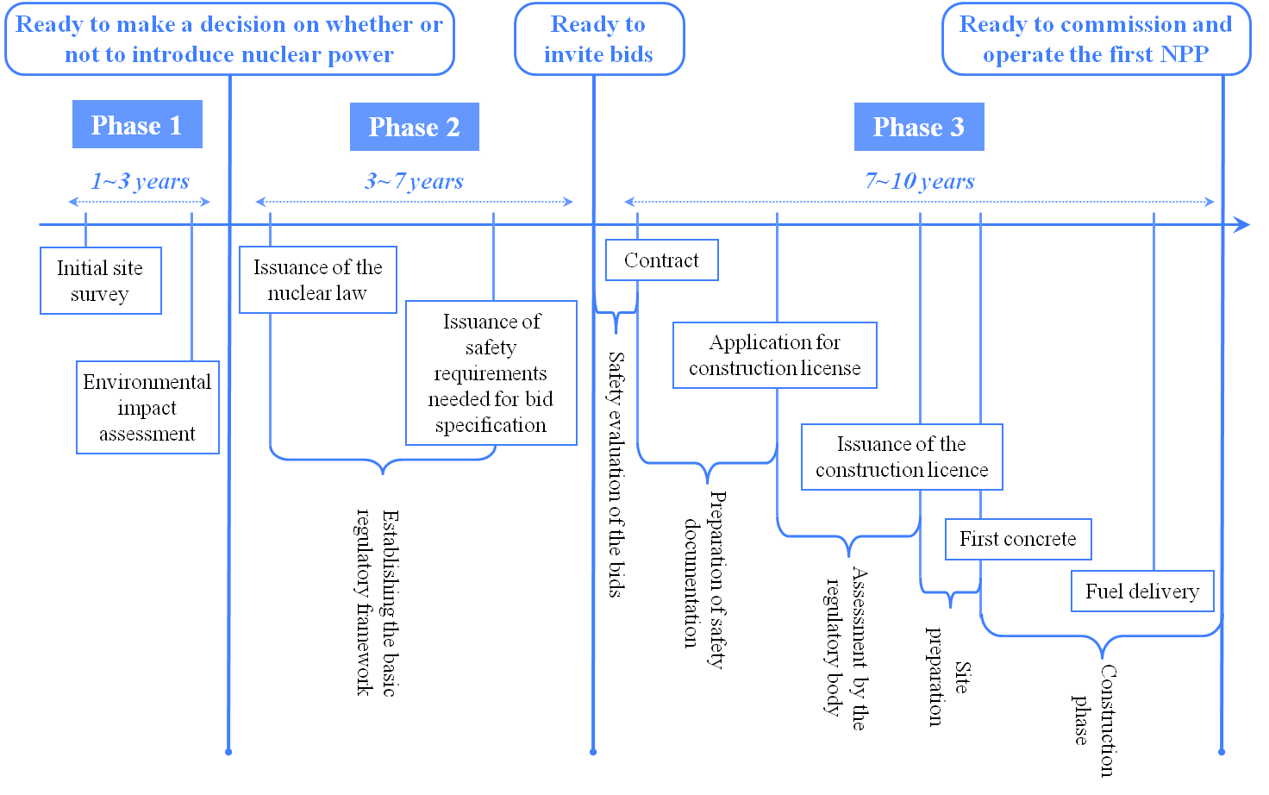

Figure 1: Activities during the first three phases of a nuclear power programme

The Nuclear Safety Act was enacted in 2012 establishing the Lilliput Nuclear Safety Authority (LNSA) as an independent regulatory body. Since established, LNSA has initiated activities and some processes in order to develop the regulatory framework of nuclear safety. However, LNSA does not yet have the full capabilities to regulate nuclear safety and additional regulatory safety requirements that the utility needs to include in its bid specification. Most of the work regarding initial site survey for NPP and environmental impact assessment (EIA) has been carried out by the relevant organizations. Later on, according to the national plan, LNU will submit to LNSA the EIA and site evaluation report.
Preliminary Safety Analysis Report (PSAR) will be submitted in phase 3 to support the design-construction application. After regulatory review and assessment, when satisfied itself with the application, LNSA will issue the ‘construction’ license. Upon receiving construction license, first concrete pouring could be started in middle of phase 3. The Final Safety Analysis Report (FSAR) is expected to be submitted probably in early phase 4 (operation phase). Major milestones of the nuclear power programme are given in figure 1.
  - Functions of LNSA
The 2012 Nuclear Safety Act assigns to LNRA the responsibility to regulate nuclear safety of the expected NPP. LNSA is also tasked by this Act, to contribute to the public information and to advise the Government, especially as regards international commitments to be fulfilled by Lilliput. According to this mandate, LNSA is required to discharge the following core and support functions will in order to fulfill its legal obligations:
    - Core Functions
  - Regulations and Guides
  - Authorization
  - Review and Assessment
  - Inspection and Enforcement
    - Support Functions
  - International Co-operation and Public Information
  - Research and Development related to nuclear safety
  - Human Resource Development
  - Organization of LNSA
Organizational structure of LNSA is given in Figure 2.

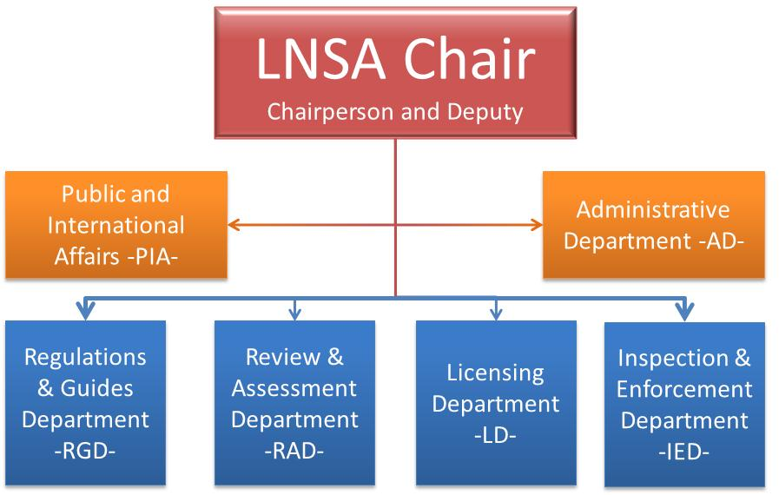

Figure 2: Organizational chart of LNSA

The LNSA Board comprises the Chairperson and Deputy-Chairperson as well as the departments’ Heads.
LNSA has started to recruit staff from universities and other industries, including a few experienced individuals from other regulatory bodies, considering the budget limitation given by the government.
The role and functions of each department as described in the following paragraphs.
    - Regulations and Guide Department (RGD)
Regulations and Guide Department (RGD), located at Head Quarter, is responsible for establishing or, possibly, adopting regulations and guides in order to specify the principles, requirements and associated criteria for safety upon which the LNSA regulatory judgments, decisions and actions are based.
Functions
- Formulation and issuance of LNSA Policies, including regarding approach adopted by LNSA.
- Supervision and Coordination of drafting, adoption, review and revision as necessary, and repeal of LNSA regulations.
- Supervision and Coordination of drafting, review revision of LNSA guides.
- Review and acquire approval of LNSA level internal working procedures.
- Provide legal opinion on implications of LNSA Regulations under the 2012 Nuclear Safety Act.
- Gazette notification of Regulations.
- Coordinate, Review and finalize RB comments on IAEA draft safety standards.
    - Nuclear Authorization Department (NAD)
Nuclear Authorization Department (NAD), located at Head Quarter, is responsible for the licensing process of NPP.
Functions
- Licensing of nuclear power plants and manufacturers of nuclear safety class equipment.
- Inspections and enforcement during all phases of nuclear power plants (Siting, Construction, Operation, Decommissioning, etc.) to support any licensing decision
- With the support of RAD, review and assessment of submissions of NPPs and equipment manufacturer.
- Reporting the summary on the safety of NPPs on quarterly basis to the Senior Management.
    - Review & Assessment Department (RAD)
Review and Assessment Department (RAD) is located at Head Quarter.
Functions
- Overall, to support the other technical departments in respect of issues on nuclear safety-related review and assessment. Safety analysis conducted by RAD includes the following areas:
    - Design bases Accidents (DBA)
    - Beyond Design bases Accidents
    - Probabilistic Safety Assessment
    - Structural analysis
    - Seismic analysis
    - Computational Fluid Dynamics and Stress Analysis
    - Human and organizational factors
    - Integrated management system
- Assistance of NAD in the review and assessment of licensees application contents, i.e.:
    - Safety analysis reports (SARs)
    - Periodic safety reviews
    - Commissioning programme
    - Decommissioning
    - Operating procedures
    - Emergency Preparedness Program etc.
    - Review of events/reports related to NPP
    - Audit Calculation of NPPs and Research Reactors SAR
    - Review of design modifications related to NPPs.
- Assistance in regulatory inspections, including during:
    - Manufacturing of NPPs components
    - Outages
    - Major modification and replacement (i.e., NPP Boilers tube bundles)
- Research & development in Safety Analysis:
    - Cost estimation of DBAs as a bases for Civil Liability
    - Design bases Accident Analysis
    - Design extension conditions
    - Use of International Operating Experience Feedback
    - Development of guidelines for NPP PSA.
    - Inspection & Enforcement Department (IED)
Inspection & Enforcement Department (IED) is located simultaneously at head quarter and near the future NPP site. IED is responsible for inspection and enforcement actions during construction, operation of NPP, including outages.
Functions
- Inspection and enforcement of nuclear power plants.
- Interface with NPP licensee during construction, installation, commissioning and operation phases.
- Oversight of Leadership and management for safety, as well as safety culture (?)
- Training of occupational radiation workers.
- Coordination with National Radiological emergency Control Center (NRECC) during nuclear & radiological emergencies exercises.
    - Public and International Affairs (PIA)
The Public and International Affairs Department (PIA) is located at head quarter of LNSA. It is responsible to propose and implement the strategic plan for communication with the public and other interested parties, including regulatory bodies of other countries and international organizations, such as the IAEA.
    - Administrative Department (AP)
The Administrative Department (PIA) is located at head quarter of LNSA. It is responsible for financial, human resources and knowledge management as well as other administrative support functions of LNSA.
  - Integrated Management System of LNSA
The LNSA Chairperson has appointed John as Senior Manager of the LNSA Integrated Management System (IMS), responsible to manage its development and implementation. Previously, John was Quality Manager in another organization in Lilliput, not involved with nuclear issues.
During a recent meeting, the Chairperson has asked John to focus on the most important elements of the IMS and processes considering the current status of the development of LNSA. The Chairperson pointed out that limited time is available to complete this task. She also emphasized that this activity should be done in consultation with different departments and, when appropriate, in relation with LNU. Moreover, she requires to be consulted when there is a need to formally consult other national agencies or Governmental organizations in order to deal properly with IMS interfaces between LNSA and them. At last, the Chairperson wants to be kept informed about the development of IMS.
The Chairperson has allowed John to suggest a team building to achieve his mission, and to look for international good practices for nuclear regulatory bodies.
- Overall instructions to carry out the exercises
- Participants are required to form groups usually of 3 to 5 persons
- Each group is requested to identify a group facilitator as well as a rapporteur.
- Allocated time is specified for each exercise.
- Groups are required to work as team and to complete the tasks.
- Groups have to prepare a 10 minute power point presentation of key findings that will presented by the group rapporteur.
- Lecturers will be available to answer any query during exercise.

Annex
Additional instruction for workshop facilitators
The workshop facilitators should select, tailor and use the exercises according to: the participants and their actual needs, the member state(s) specific situation(s), and the specific actions associated with each phase.
They should proactively interact with the participants where appropriate.

